**Session 8**

**Depth Perception and Applications in Robotics**

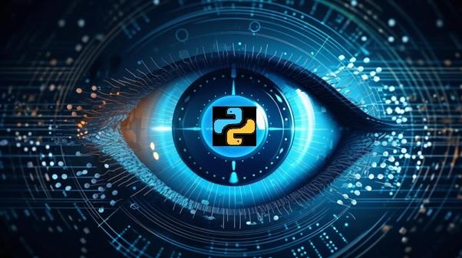



**Objectives**

* Explain the basics of stereo vision for depth perception
* Describe LiDAR technology and its role in depth sensing
* Describe the concept of depth perception and its applications in robotics
* Explain the fundamentals of point clouds
* Explain the integration of depth perception in robotics

**8.1 Principles of Stereo Vision and LiDAR**

Stereo Vision and LiDAR are two techniques which are used by modern robotics to visually sense the world.

**8.1.1 Basics of Stereo Vision**

Stereo vision, also known as stereopsis, is a technique used in computer vision and robotics that mimics human binocular vision. It involves capturing and processing images from two or more cameras to perceive depth and create a three-dimensional (3D) representation of the environment.

**Working Principle:**

Stereo Image Pair: Stereo vision requires at least two cameras placed at different positions, capturing images simultaneously. The images obtained from these cameras create a stereo image pair.

Disparity Map: Disparity refers to the pixel-level differences between the images in the stereo pair. By calculating the disparity, the depth information can be derived.

Depth Perception: The brain processes the pixel disparities to perceive depth, similar to how human eyes create depth perception.

**Applications:**

Obstacle Avoidance: Robots use stereo vision to detect obstacles and navigate around them.

Object Recognition: Stereo vision aids in recognizing and localizing objects in the environment.

3D Mapping: It contributes to the creation of accurate 3D maps for robotic navigation.

**8.1.2 LiDAR Technology**

LiDAR, which stands for Light Detection and Ranging, is a remote sensing technology that uses laser light to measure distances. In robotics, LiDAR is employed for precise depth sensing and environmental mapping.

**Working Principle:**

Laser Emission: LiDAR systems emit laser beams toward the surroundings.

Time-of-Flight Measurement: The system measures the time it takes for the emitted laser pulses to return after hitting an object. Based on the time-of-flight, the distance to the object is calculated.

360-Degree Scanning: LiDAR sensors often rotate or use multiple lasers to scan the environment from all directions.

**Applications:**

Autonomous Vehicles: LiDAR is a key technology for self-driving cars, providing real-time 3D mapping for navigation.

Surveying and Mapping: Used for creating high-resolution topographic maps and surveying terrains.

Environmental Monitoring: LiDAR aids in monitoring and assessing changes in vegetation, terrain, and infrastructure.

**8.2 Depth Perception Techniques: Unveiling the Spatial Dimension**

Depth perception is a cornerstone in robotics, unlocking the spatial dimension for machines to interpret and navigate their environment. This section delves into various techniques employed for depth perception, shedding light on their principles and applications in the realm of robotics.

**8.2.1 Understanding Depth Perception**

Depth perception, the ability to perceive the world in three dimensions, is a cognitive marvel that robots strive to emulate. By comprehending the spatial relationships and distances between objects, robots equipped with depth perception capabilities can navigate, interact, and function more effectively.

Techniques for Depth Perception:

Stereo Vision: Utilizes the slight disparities between images captured by two or more cameras to calculate depth.

Monocular Cues:

Depth cues perceived with a single camera, including:

* Size Disparity: Objects of known size appear smaller when farther away.
* Overlap (Occlusion): Objects in front may partially or fully cover those behind them.
* Linear Perspective: Parallel lines converge as they extend into the distance.

Motion Parallax: Observing the relative motion of objects at different distances to estimate their depth.

Focus Cues: Utilizing the eye's ability to adjust focus based on the distance of an object.

**8.2.2 Applications in Robotics**

Robotics Applications of Depth Perception:

* Obstacle Avoidance: Robots use depth perception to detect obstacles and plan collision-free paths.
* Object Recognition and Manipulation: Enables robots to recognize objects in their environment and manipulate them with accuracy.
* Autonomous Navigation: Vital for autonomous vehicles and drones to navigate through dynamic and varied terrains.
* Human-Robot Interaction: Depth perception enhances the robot's ability to interact with humans by understanding their gestures and positions.
* Surveillance and Security: Depth perception aids in monitoring and tracking objects or individuals within a given space.

Understanding depth perception is fundamental for robots to operate effectively and safely in real-world scenarios, making it a crucial aspect of robotic systems design and implementation.

Importance in Robotics:

* Navigation: Helps robots navigate through complex environments, avoiding obstacles and planning efficient paths.
* Object Manipulation: Enables robots to grasp and manipulate objects with precision.
* Environment Understanding: Enhances a robot's ability to interpret and interact with its surroundings.

**8.3 Point Cloud Processing Basics**

Point clouds serve as a rich source of spatial information, capturing the intricate details of a physical environment. This section explores the fundamental aspects of point cloud processing, from their introduction to the techniques used for analysis and feature extraction.

**8.3.1 Introduction to Point Clouds**

Point clouds are 3D representations of surfaces, constructed by collecting a multitude of points in space. These points, often obtained through technologies like LiDAR or stereo vision, collectively create a detailed map of an object or environment.

**Characteristics:**

XYZ Coordinates:

Each point in the cloud is defined by its X, Y, and Z coordinates in the 3D space.

Density:

The density of points determines the level of detail in the representation, with higher densities capturing finer features.

Color and Intensity:

Point clouds may include additional information such as color or intensity, enhancing the visual representation.

For working with point cloud, the developer can use open3d library of python to render the point cloud and see how point cloud looks.

To install all the necessary packages use this command in command line:

| pip install open3d |
| --- |

To download the point cloud file down any sample from this [site](https://people.sc.fsu.edu/~jburkardt/data/ply/ply.html).

**Code Snippet 1**

| import numpy as np  import open3d as o3d  print("Load a ply point cloud, print it, and render it")  ply_point_cloud = './airplane.ply'  pcd = o3d.io.read_point_cloud(ply_point_cloud)  print(pcd)  print(np.asarray(pcd.points))  o3d.visualization.draw_geometries([pcd]) |
| --- |

In the code snippet 1 the developer utilizes the Open3D library to load a 3D point cloud from a PLY file named **'airplane.ply'**. It prints information about the point cloud object, including its geometry details, and displays the coordinates of the points as a NumPy array. Finally, it visualizes the point cloud using the draw_geometries function from Open3D, providing an interactive 3D rendering of the loaded point cloud.

**Figure 8.1: Output of code snippet 1 rendered ply file**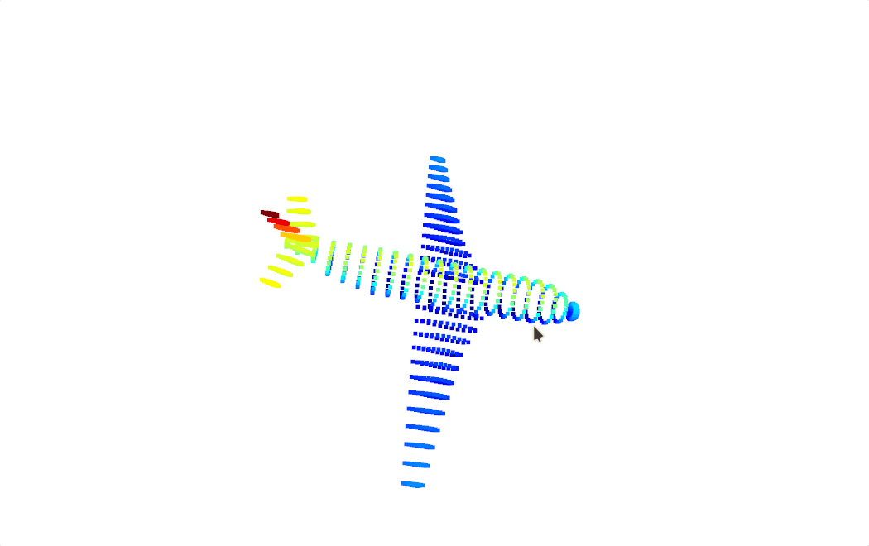

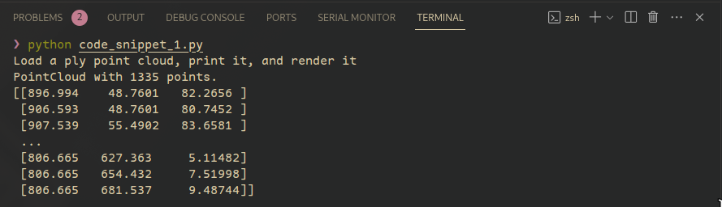

**Figure 8.2: Output of code snippet 1**

The output consists of three parts: Firstly, it confirms the successful loading of a point cloud with 1335 points. Secondly, it prints a snippet of the point coordinates as a NumPy array, illustrating the spatial distribution. Lastly, a separate window opens, visually presenting an interactive 3D rendering of the loaded point cloud, enabling exploration of its geometry as shown in figure 8.1.

**8.3.2 Processing and Analysis**

To use Point cloud effectively, it has to be processed and analyzed.

**Processing Steps:**

Data Acquisition:

Obtain point cloud data through sensors like LiDAR or stereo cameras.

Registration:

Align multiple point clouds into a common coordinate system for comprehensive mapping.

Downsampling:

Reduce data size by removing redundant points while preserving essential details.

Normalization:

Normalize point cloud data for consistent scales and orientation.

**Analysis Techniques:**

* Surface Reconstruction: Reconstructing surfaces from point cloud data for a comprehensive 3D model.
* Object Recognition: Identifying and categorizing objects within the point cloud.
* Change Detection: Analyzing differences between multiple point cloud captures to identify changes in the environment.

**8.3.3 Filtering and Segmentation Techniques**

**Filtering:**

* Noise Removal: Eliminate outliers and sensor-generated noise for cleaner data.
* Smoothing: Apply filters to reduce irregularities and create a smoother representation.

**Segmentation**:

* Region Growing: Identify connected regions with similar properties.
* Plane Segmentation: Separate point clouds into distinct planes, aiding in surface analysis.

**8.3.4 Feature Extraction from Point Clouds**

**Features:**

* Curvature: Identify regions with varying surface curvatures.
* Edges and Corners: Detect sharp changes in the point cloud, indicating edges or corners.
* Descriptors: Extract unique characteristics for object recognition.

**Applications:**

* Object Recognition: Matching features to known objects for identification.
* Navigation: Extracting features for path planning and obstacle avoidance.
* Augmented Reality: Enhancing virtual objects' interaction with the real world.

Point cloud processing, from acquisition to feature extraction, is a critical step in leveraging 3D spatial data for applications in robotics, computer vision, and various other fields.

**8.4 Applications in Robotics and Autonomous Vehicles**

Robotics and autonomous vehicles leverage depth perception technologies to enhance their capabilities and navigate dynamic environments. This section explores the integration of depth perception in robotics, along with challenges and future developments in this rapidly evolving field.

**8.4.1 Integration of Depth Perception in Robotics**

**Enhanced Navigation:**

Obstacle Avoidance: Robots use depth perception to detect and navigate around obstacles, ensuring safe movement in cluttered environments.

Terrain Understanding: Depth perception aids in recognizing changes in terrain, helping robots adapt their locomotion for various surfaces.

**Object Manipulation:**

Precise Grasping: Robots equipped with depth perception can grasp and manipulate objects with accuracy, as they can estimate the distance and shape of the objects.

**Human-Robot Interaction:**

Gesture Recognition: Depth perception enables robots to interpret human gestures, facilitating more intuitive communication.

Safe Collaboration: Robots can work alongside humans more safely by perceiving their proximity and movements.

**3D Environment Mapping:**

Spatial Awareness: Depth perception contributes to creating detailed 3D maps of the environment, allowing robots to understand and navigate complex spaces.

**Vision-Based Control:**

Autonomous Systems: Depth perception is integral to the autonomy of robots, enabling them to make real-time decisions based on their understanding of the surroundings.

**8.4.2 Challenges and Future Developments**

**Challenges in Depth Perception:**

1. Real-Time Processing:

Achieving fast and efficient processing of depth data in real-time applications is a persistent challenge.

2. Adaptation to Dynamic Environments:

Ensuring robust depth perception in environments with changing lighting conditions, moving objects, or varying terrains.

3. Sensor Limitations:

Overcoming limitations of sensors, such as the range and accuracy of LiDAR or stereo vision systems.

4. Integration with Other Sensors:

Integrating depth perception seamlessly with other sensors for a holistic understanding of the environment.

**Future Developments:**

1. Advanced Sensor Technologies:

Continued advancements in LiDAR, stereo vision, and other depth sensing technologies for improved accuracy and range.

2. Machine Learning Integration:

Utilizing machine learning algorithms to enhance depth perception capabilities, allowing systems to learn and adapt to diverse scenarios.

3. Multi-Modal Sensor Fusion:

Integrating depth perception with data from other sensors, such as cameras and inertial sensors, for a more comprehensive understanding of the environment.

4. Edge Computing:

Implementing edge computing solutions to process depth data on-board, reducing latency and improving real-time performance.

5. Standardization of Depth Data Formats:

Establishing standardized formats for depth data exchange to promote interoperability among different robotic systems.

The integration of depth perception in robotics presents exciting opportunities for innovation. Overcoming current challenges and embracing future developments will play a pivotal role in realizing the full potential of depth sensing technologies in autonomous systems.

**Summary**

* Stereo vision utilizes two cameras to calculate depth, while LiDAR measures distances using laser beams.
* Depth perception involves perceiving the world in three dimensions, employing techniques like stereo vision, monocular cues, motion parallax, and focus cues.
* Point clouds are 3D representations created by collecting numerous points in space, with processing steps including data acquisition, registration, downsampling, and normalization.
* Analysis techniques for point clouds encompass surface reconstruction, object recognition, and change detection.
* Integration of depth perception in robotics enhances navigation, object manipulation, and human-robot interaction.
* Applications include obstacle avoidance, terrain understanding, precise grasping, 3D environment mapping, and vision-based control.
* Challenges in depth perception include real-time processing, adaptation to dynamic environments, and sensor limitations.
* Future developments involve advanced sensor technologies, machine learning integration, and standardized depth data formats.
* Depth perception is fundamental for robots, providing the ability to understand and interact with a 3D environment, with ongoing advancements shaping the field.

**Check Your Progress**

1. What is the primary role of LiDAR technology in robotics?

| **A** | Object recognition | **B** | Depth sensing |
| --- | --- | --- | --- |
| **C** | Surface reconstruction | **D** | Human robot interaction |

1. Which technique utilizes the slight disparities between images captured by two or more cameras to calculate depth?

| **A** | Monocular cues | **B** | Motion parallax |
| --- | --- | --- | --- |
| **C** | Stereo vision | **D** | Focus cues |

1. What is a common application of point clouds in robotics?

| **A** | Image recognition | **B** | Audio processing |
| --- | --- | --- | --- |
| **C** | 3D environment mapping | **D** | Temperature sensing |

1. In point cloud processing, what is a key step in downsizing the data without losing essential details?

| **A** | Normalization | **B** | Registration |
| --- | --- | --- | --- |
| **C** | Downsampling | **D** | Analysis |

1. What is one of the challenges associated with depth perception in robotics?

| **A** | Reducing sensor accuracy | **B** | Real time processing |
| --- | --- | --- | --- |
| **C** | Minimizing sensor range | **D** | Ignoring environmental changes |

**Answers to Check Your Progress**

| Question | Answer |
| --- | --- |
| 1 | B: Depth sensing |
| 2 | C: Stereo vision |
| 3 | C: 3D environment mapping |
| 4 | C: Downsampling |
| 5 | B: Real-time processing |

**Try It Yourself**

1. Apply basic point cloud processing techniques using the open3d library in Python.